LiDAR-BASED
OBSTACLE DETECTION
EVALUATION GUIDE
Build, launch, and evaluation procedure for the ROS 2 obstacle detector
ROS 2 • LiDAR Scan Processing
Version 1.0
Date: July 2026

Table of Contents
1. Overview
2. System Architecture
3. Prerequisites
4. Workspace Structure
5. Build and Launch Workflow
6. Expected Output
7. Visualization (Optional)
8. Evaluation Procedure
9. Expected Results
10. Troubleshooting

1. Overview
This document describes the procedure for building, launching, and evaluating the LiDAR-Based Obstacle Detection package. The node processes LiDAR scan data to detect obstacles within a specified field of view and publishes the obstacle information for downstream navigation and decision-making modules.

2. System Architecture
The diagram below shows how scan data flows from the sensor through the obstacle detector to downstream consumers.
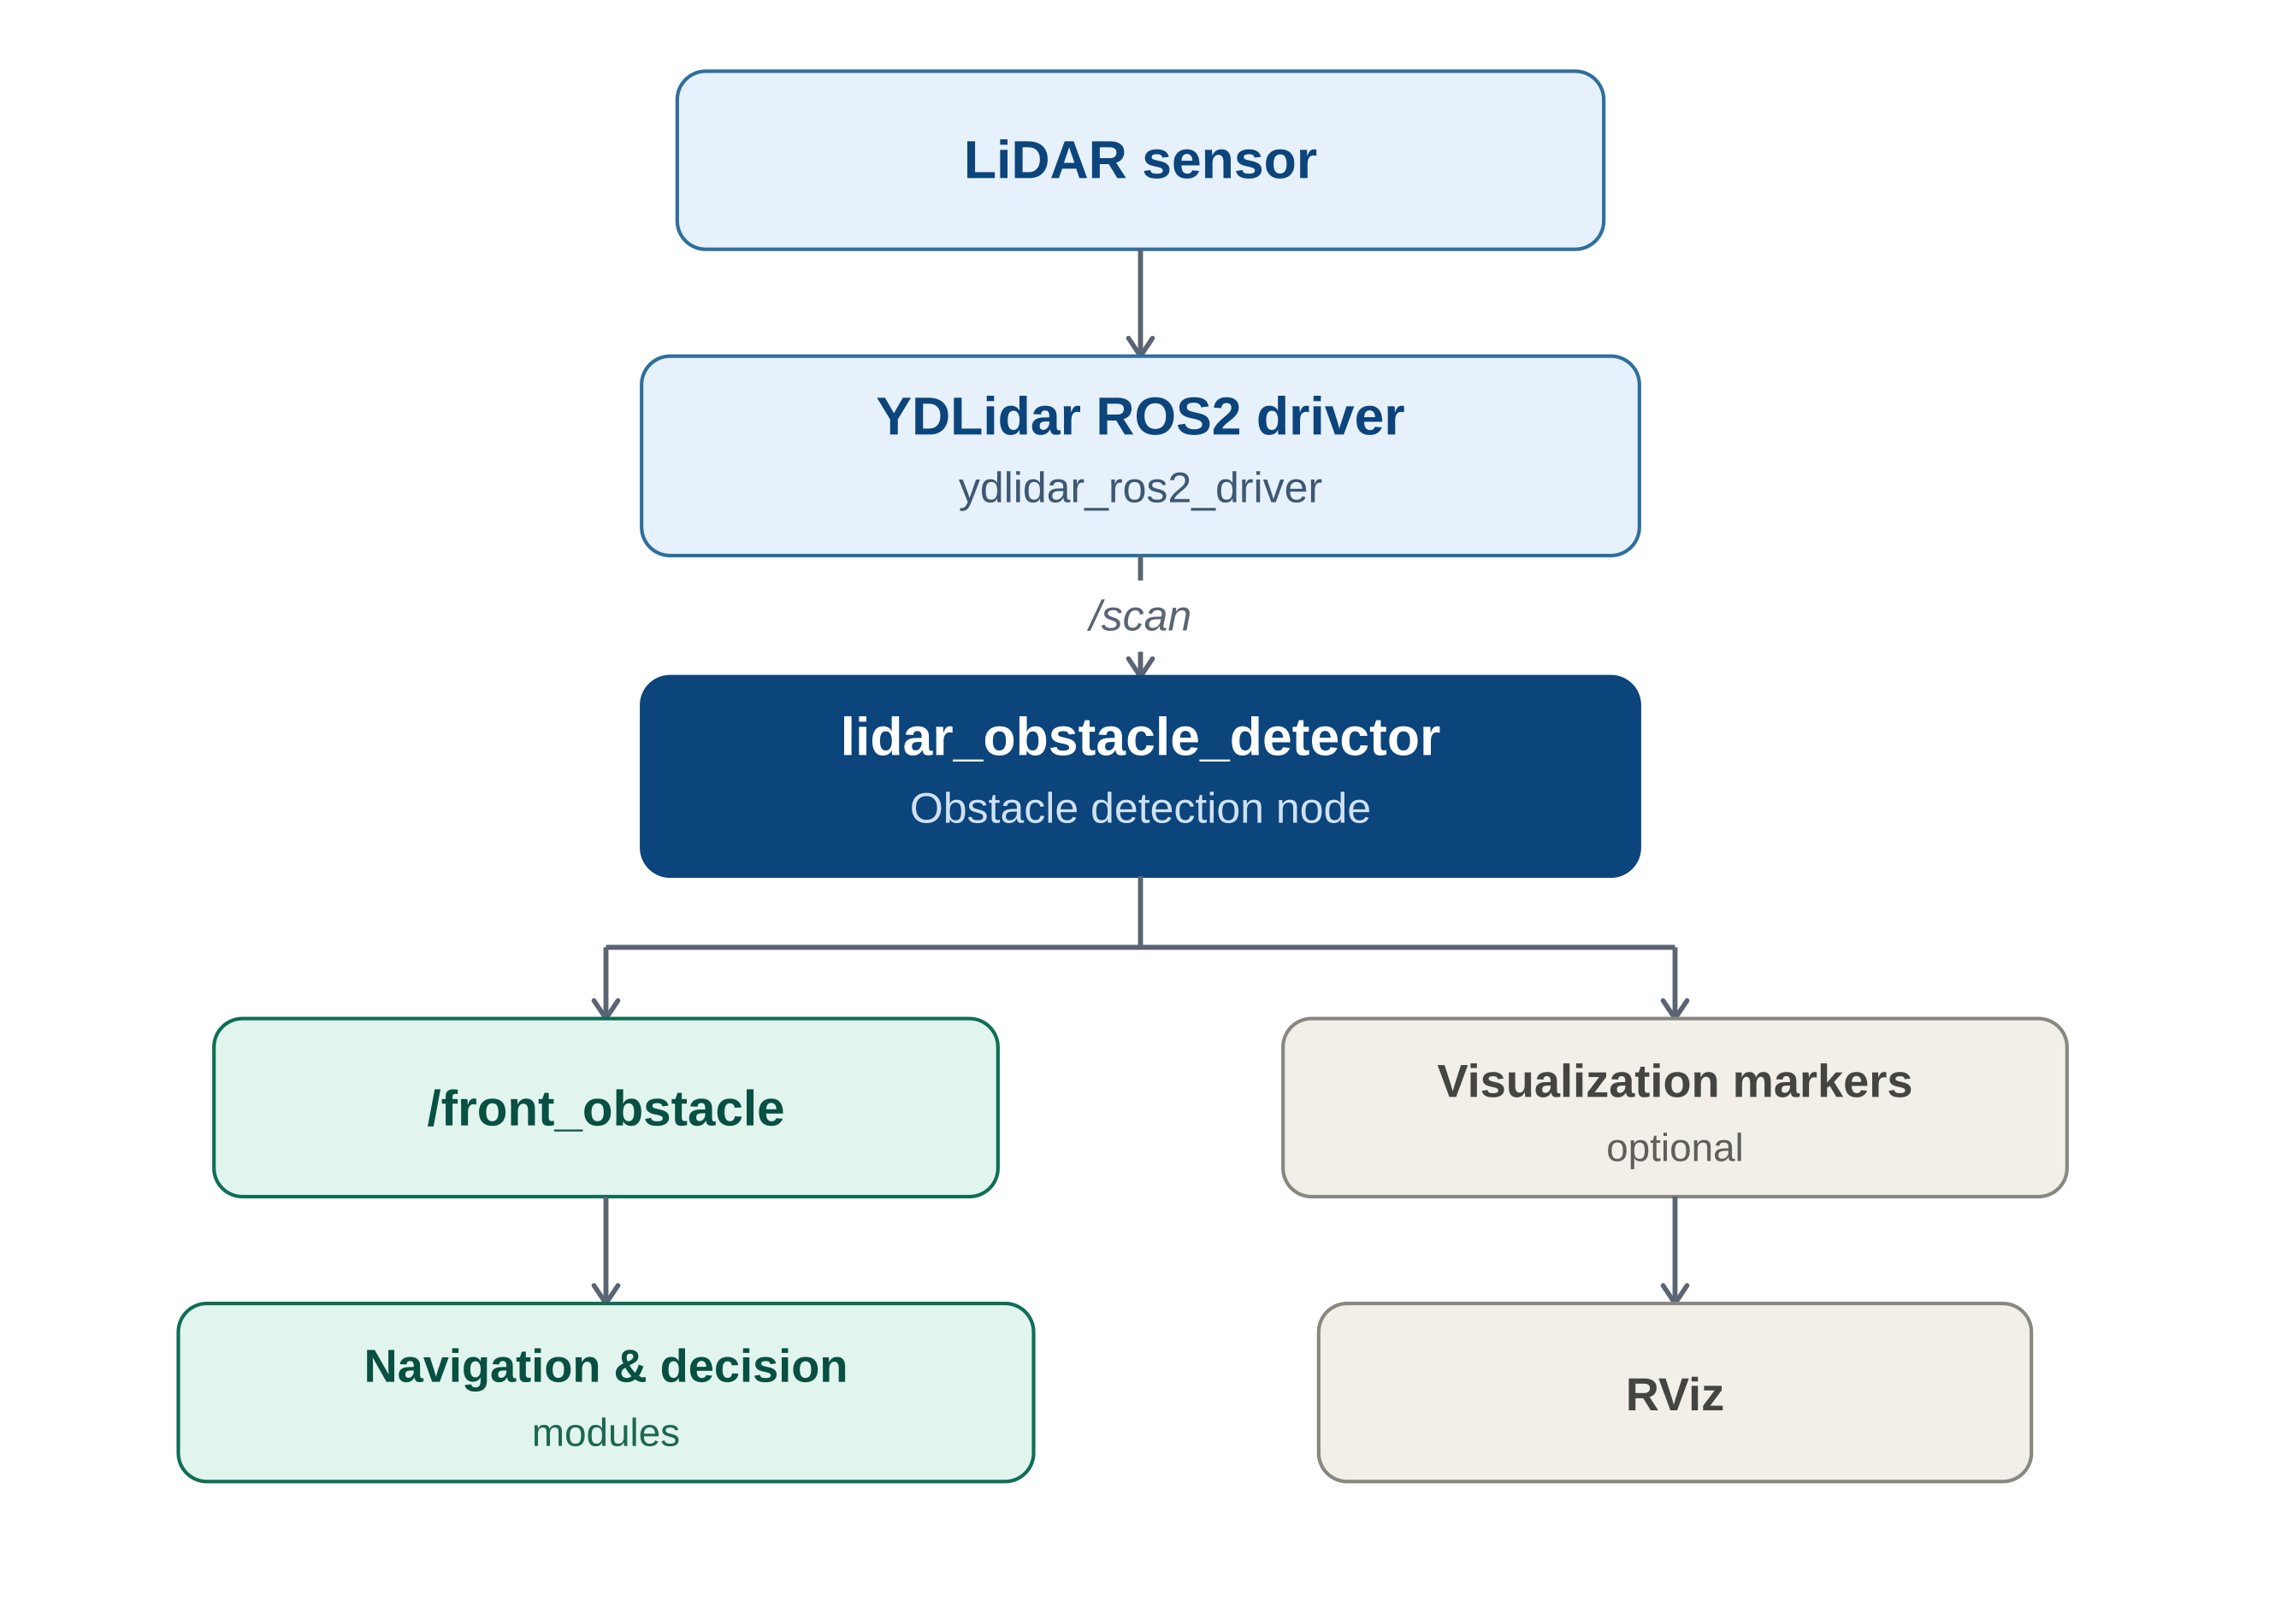
Figure 1 — Obstacle detection system architecture

3. Prerequisites
Ensure the following requirements are met before running the package:
✓ ROS 2 workspace is created and configured.
✓ LiDAR ROS 2 driver is installed (e.g., YDLidar ROS 2 Driver).
✓ obstacle_msgs package is available in the workspace.
✓ lidar_obstacle_detector package is copied into the workspace.
✓ LiDAR sensor is connected and functioning correctly.

4. Workspace Structure
Copy the following packages into the src directory of your ROS 2 workspace.
<ros2_workspace>/
└── src/
├── obstacle_msgs/
├── lidar_obstacle_detector/
└── ...

5. Build and Launch Workflow
The diagram below summarizes the full sequence from building the packages to verifying published obstacle data.
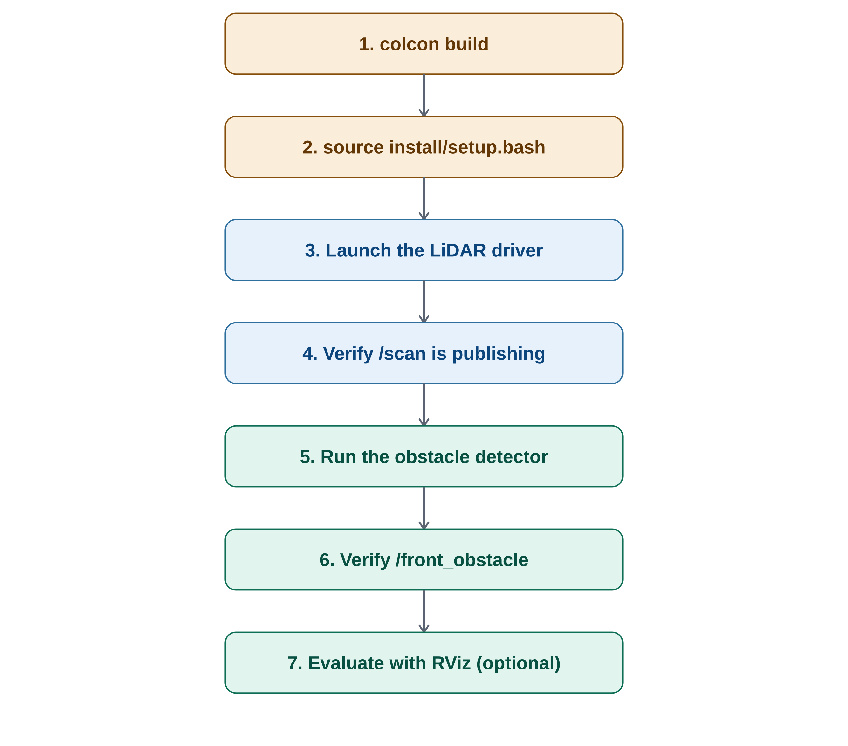
Figure 2 — Build, launch, and verification workflow

Build the Packages
Navigate to the root of your ROS 2 workspace, then build the complete workspace:
colcon build --symlink-install
...or build only the required packages:
colcon build --packages-select obstacle_msgs lidar_obstacle_detector

Source the Workspace
After a successful build, source the workspace.
source install/setup.bash

Launch the LiDAR Driver
Start the LiDAR driver and wait until it starts publishing scan data.
ros2 launch ydlidar_ros2_driver ydlidar_launch.py

Verify LiDAR Scan
Confirm that the LiDAR is publishing data.
ros2 topic list
The /scan topic should be available. Verify the scan data:
ros2 topic echo /scan

Run the Obstacle Detection Node
Open a new terminal, source the workspace, and run the obstacle detection node.
source install/setup.bash
ros2 run lidar_obstacle_detector obstacle_detector

Verify Published Topics
The obstacle detection node subscribes to /scan and publishes /front_obstacle. To verify obstacle messages:
ros2 topic echo /front_obstacle

6. Expected Output
When an obstacle is detected within the configured detection region, the node publishes information such as:
- Obstacle position (X coordinate)
- Obstacle position (Y coordinate)
- Distance from the LiDAR
- Estimated obstacle width

Example:
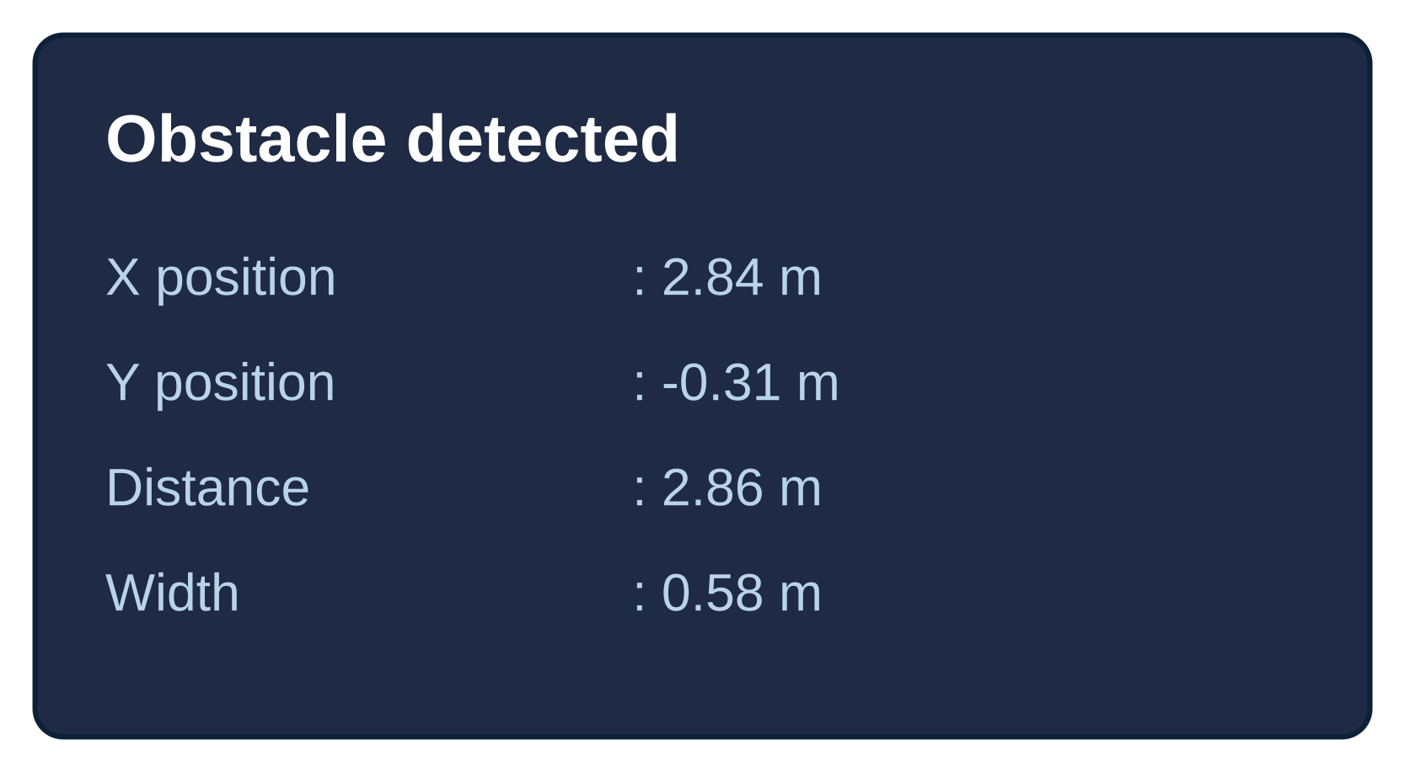
Figure 3 — Example /front_obstacle message

7. Visualization (Optional)
The package can also publish visualization markers for RViz. Launch RViz and add the following displays:
- LaserScan
- Marker
- TF
This allows visual verification of:
- LiDAR point cloud
- Detected obstacle location
- Obstacle bounding marker

Continue...

8. Evaluation Procedure
The diagram below summarizes the recommended evaluation procedure, including the checks to perform at each step.
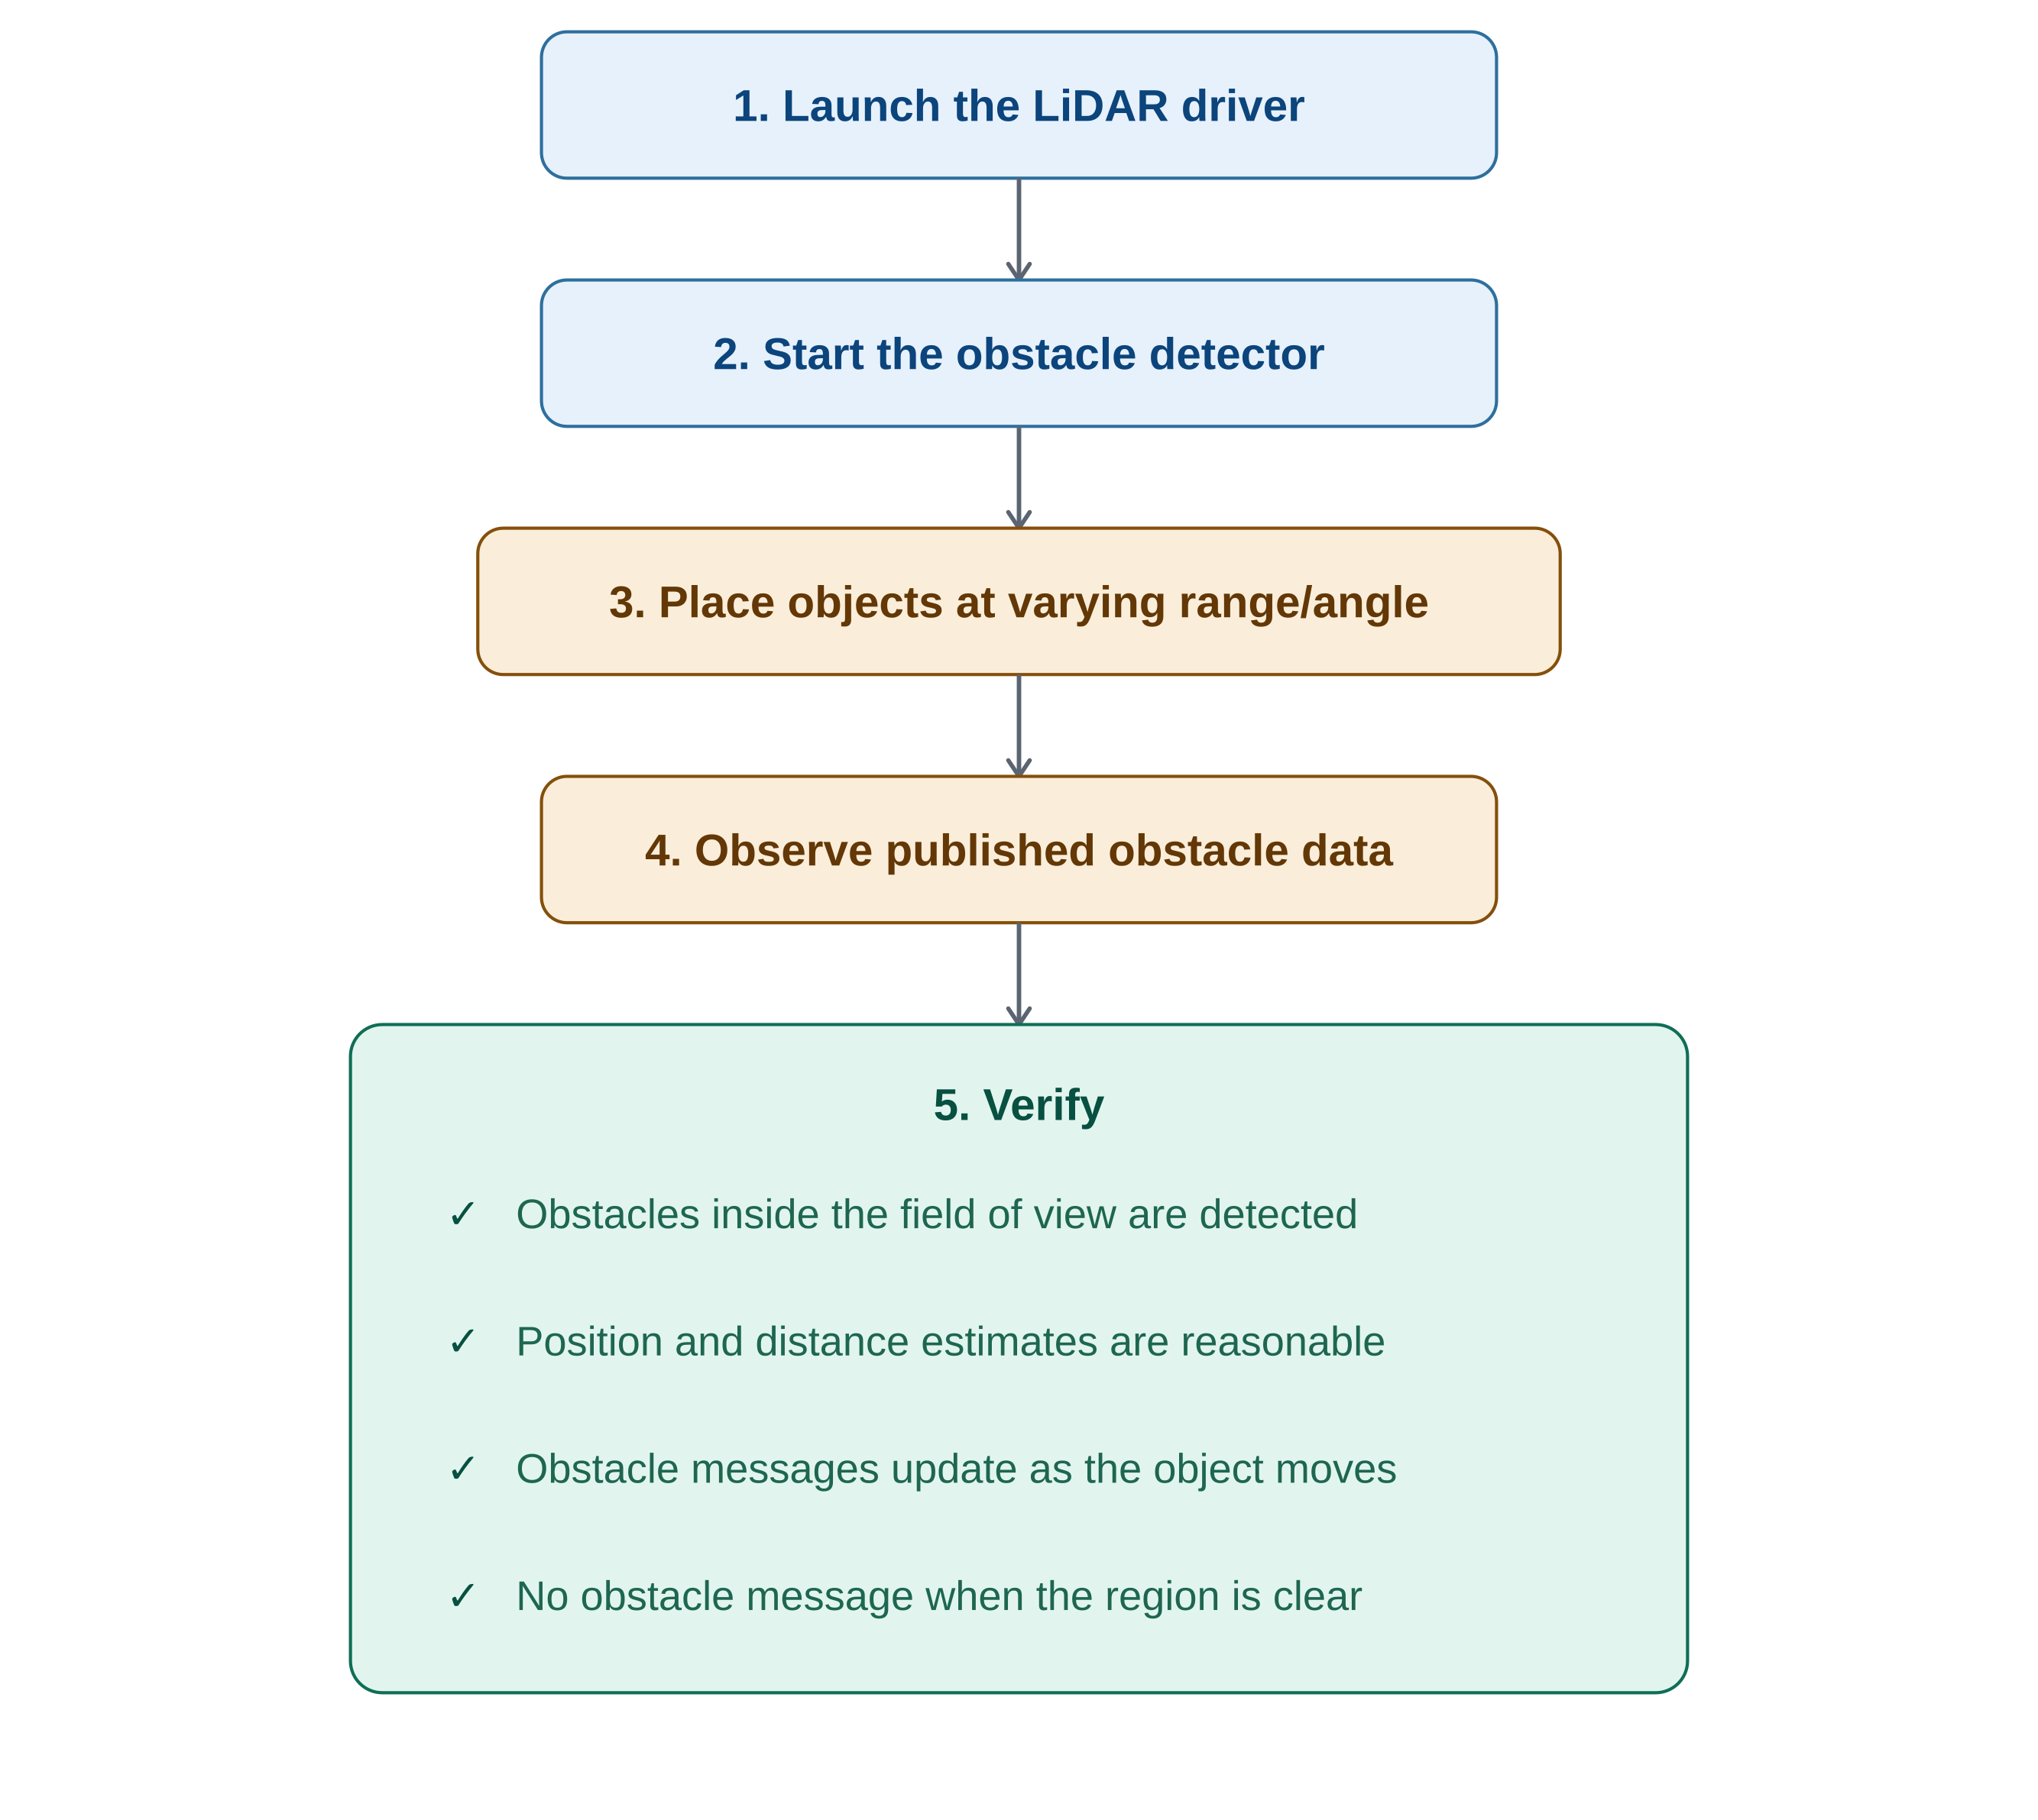
Figure 4 — Evaluation procedure and verification checklist

9. Expected Results
The obstacle detector should:
✓ Continuously subscribe to LiDAR scan data.
✓ Detect obstacles within the configured detection field.
✓ Estimate obstacle position and width.
✓ Publish obstacle information in real time.
✓ Update detections dynamically as obstacles move.

10. Troubleshooting
Issue | Possible Cause | Solution
/scan topic not available | LiDAR driver not running | Launch the LiDAR driver and verify the sensor connection.
/front_obstacle topic not available | Obstacle detector not running | Ensure the obstacle detection node is launched successfully.
No obstacles detected | Object outside detection region or beyond sensing range | Move the object into the configured field of view and verify LiDAR operation.
Build errors | Missing dependencies or packages | Confirm that obstacle_msgs and lidar_obstacle_detector are present in the workspace and rebuild the packages.
Incorrect obstacle position | TF configuration or LiDAR mounting mismatch | Verify the LiDAR frame configuration and transform settings.

